Lecture 3
FUNCTIONS OF THE CELL MEMBRANE
Membrane structure and Organisation
i. Biological membranes are composed of phospholipid bilayer structure in which protein molecules are either partially or wholly embedded. Phospholipids spontaneously arranged themselves into two layers (bilayer): the hydrophilic (water loving) polar head of the phospholipid molecules face the outside and inside of the cell where water is found. The hydrophobic (water hating) non polar tails face each other.
ii. Based on location, cell membrane proteins are divided into two: integral and peripheral proteins. The integral proteins are found within the membranes and have hydrophobic regions embedded within the membranes while the hydrophilic regions project outwards from both surfaces of the bilayer. Peripheral proteins occur either on the outside or the inner surface of the membrane.
Based on functions, membrane proteins can also be classified into three: structural proteins, enzymes and carrier proteins. The structural proteins form part of the membrane; the carrier proteins are involved in transport across membranes while enzymes perform catalysis.

Summary of general features shared by membranes from different organelles or cells:
1. Impermeability to polar molecules or ions except through a specific transporter for that molecule or ion
2. Flexible, non-rigid to allow for cellular or organellar changes in shape and size
3. Durability; usually resistant to damages or remarkable ability to reseal quite quickly and surviving for the lifetime of the cell
4. A trilaminar appearance of two dark lines separated by a lighter space when viewed with an electron microscope
Presence of proteins – peripheral and integral proteins are not only structural but have a variety of other functions including enzyme activity, signaling, and receptors or as transporters.

The Functions of Plasma Membranes
i. Protection: The plasma membrane protects the cytoplasm and the organelles present in the cytoplasm. It is responsible for the maintenance of shape and size of cells. The most important function of cell membrane is transportation and regulation of materials across the membrane.
ii. Transportation of materials across the cell membrane: The cell membrane act as semi permeable membrane which allows only some substances to pass through it and act as a barrier for other substances. For example, small hydrophobic molecules such as CO2, O2 and small lipids dissolve in the membrane and pass through readily. Tiny polar molecules such as H2O and alcohol can also slip between the phospholipids molecules.
Ions and most nutrient molecules do not move freely through the membrane, but are often carried by the transport protein channels, either with or without the use of energy.
Gradients are important in moving materials through membranes both passively (without the use of energy by the cell) and actively (transport requiring cell energy).
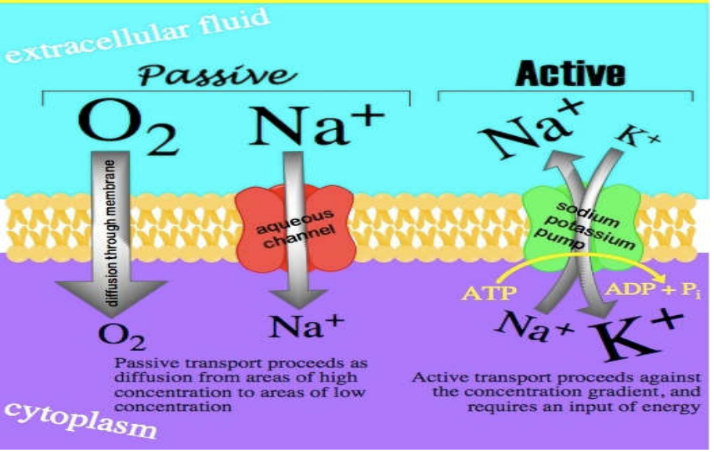
Fig 6: Passive Transport - Passive Transport in Cells Involves the Process of Diffusion, the Diffusion can be simple or facilitated.

Factors that affect passive diffusion across membranes
1. Concentration gradient across membrane.
2. Electrical potential across the membrane.
Membrane potential arises when there is a difference in the electrical charge on the two sides of a membrane, due to a slight excess of positive ions over negative ones on one side and a slight deficit on the other.
3. Permeability coefficient of the substances for the membrane.
Permeability coefficient is a term used in biology and chemistry to describe the rate at which a substance moves through a permeable membrane.
4. Hydrostatic pressure gradient across the membrane.
Any imbalance of solutes generates a pressure that leads to the flow of water molecules from lower solute to higher solute concentrations across the cell membrane.
5. Increase in ambient temperature.
Higher temperatures increase the energy and therefore the movement of the molecules, increasing the rate of diffusion. Lower temperatures decrease the energy of the molecules, thus decreasing the rate of diffusion. Solvent density: As the density of a solvent increases, the rate of diffusion decreases.
Simple diffusion – In terms of cellular activity, the rate of simple diffusion can be affected by temperature, molecular size, concentration of the gradient. Materials that are moved through membranes by simple diffusion include: water, carbon dioxide, oxygen, some lipid soluble molecules such as alcohol.
Facilitated diffusion – Most molecules cannot move freely through the membrane, but do cross membranes with the help of membrane transport proteins, which temporarily bind to the substance to be moved through the membrane, a process called facilitated diffusion or passive transport. No energy is involved in the process; both carrier proteins and channel proteins are involved in facilitated diffusion. Materials that pass through membranes by facilitated diffusion include glucose, amino acids and many small ions. The movement of water through membranes also involves facilitated diffusion, the special protein channel used for this is called aquaporins, and it facilitates the movement of water at a rate needed for cell activities.
Facilitated diffusion process may be coupled to the movement of other molecules in the same direction or opposite direction. In co-transport; the transport of one molecule depends on sequential transfer of another molecule. Co-transport may be symport or antiport. A symport moves two molecules in the same direction e.g. sodium-glucose transporter.
Antiport system moves two molecules in opposite direction, it is also known as counter transport e.g. sodium-potassium transporter.
Uniport: when a particular type of molecule moves across a membrane, through carrier protein, independent of other molecule, the diffusion is called uniport.

All cells need to move some substances through membrane in a direction counter to the gradient or move substances that are too large or bulky with the use of cell energy. Cells have a number of ways to transport materials across the cell membrane with the use of energy.
Some transport proteins (carrier proteins) can move substances through the membrane against the concentration gradient. Active transport typically requires two carrier protein active sites. One recognizes the substances to be carried while the other releases ATP to provide energy for the protein carrier. In some cases, concentration gradients of ions typically (H⁺) protons or (Na⁺) sodium ions can be used to provide the energy needed to move molecules through the membranes.
Active transport is classified into two types according to the source of energy used. Primary active transport derives its energy directly from the hydrolysis of ATP while the secondary active transport uses an indirect energy of an electrochemical gradient or membrane potential produced originally by primary active transport. An example of primary active transport is sodium-potassium pump (Na⁺ - K⁺ ATPase). It is the protein or enzyme responsible for the transportation of Na⁺ and K⁺ across the cell membrane. The enzyme is known as sodium-potassium Adenosine triphosphatase.
The energy required for the transportation of sodium and potassium ions are derived from the hydrolysis of ATP. For every three Na⁺ pumped out of the cell, two K⁺ are released into the cytosol. Physiological importance of Na⁺ - K⁺ gradient in animal cells are: the control of cell volume, it renders neurons and muscle cells electrically excitable and it drives the active transport of sugars and amino acids.

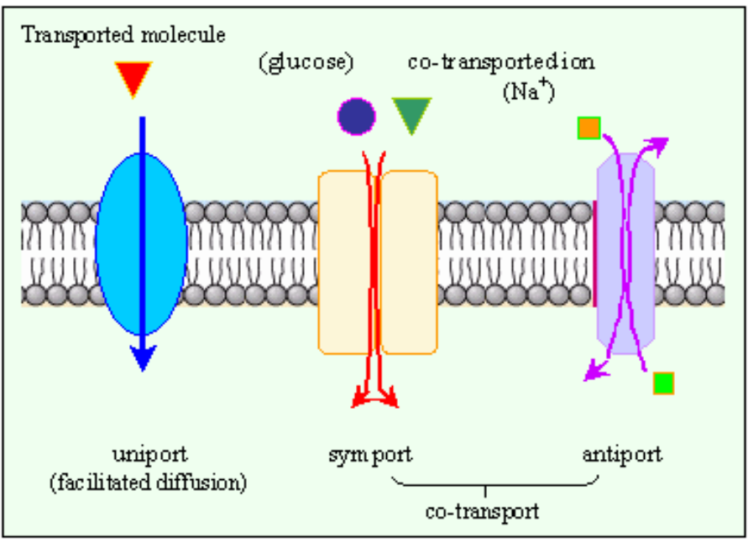

Fig. 7: Active Transport - Energy Requiring Transport across Membranes.

Endocytosis and Exocytosis
Vesicle mediated transport- Transportation of large substances may require changes in membrane shape and the fusion of the plasma membrane with vesicles containing the substances to be moved. Such changes in membranes occur throughout the life time of the cell.
Movement of materials of the cell involving changes of the membrane and formation of vesicles is called exocytosis while the movement of materials into the cell is called endocytosis.
Exocytosis- Materials can be exported from the cell by fusing vesicles with the plasma membrane. For example, insulin made inside the cells of the pancreas is released to the blood stream by exocytosis.
Endocytosis- There is a variety of endocytosis processes in the cell, examples includes pinocytosis, receptor mediated endocytosis and phagocytosis.
Pinocytosis (“pino” means “to drink”) is a process by which the cell takes in the fluids along with dissolved small molecules. In this process, the cell membrane folds and creates small pockets and captures the cellular fluid and dissolved substances.
Phagocytosis is a cellular process for ingesting and eliminating particles larger than 0.5 μm in diameter, including microorganisms, foreign substances, and apoptotic cells. Phagocytosis is found in many types of cells and it is, in consequence an essential process for tissue homeostasis.

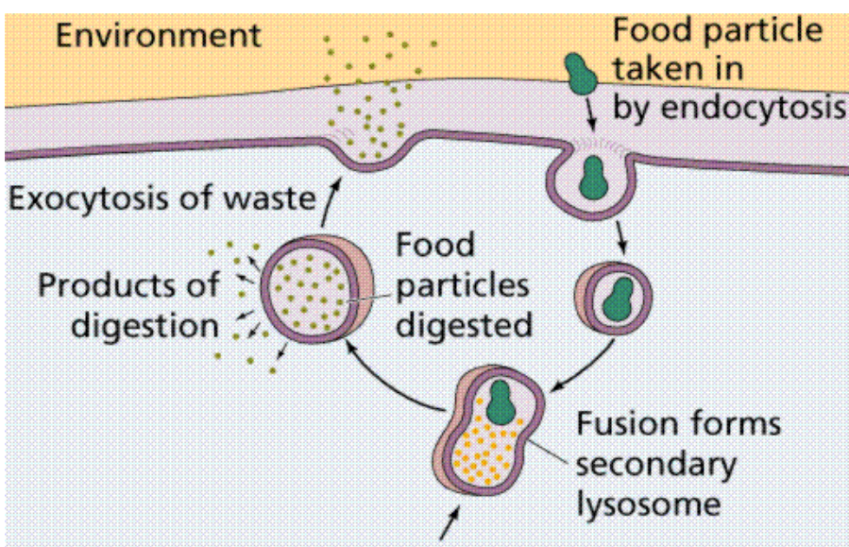

Fig. 8: Endocytosis and Exocytosis.

